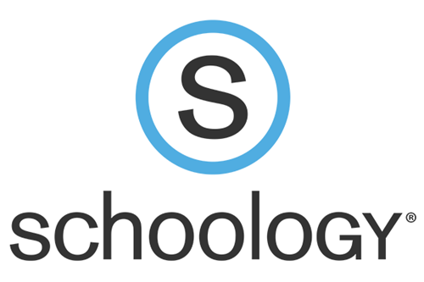
Schoology is a web-based learning management system. Teachers can create tasks/assignments, assessments, and discussions for students.

How to access Schoology:
Schoology is accessed through the Alden Home Page. Your student will need to log in using their school issued username and password. Your student can save these to their devices to stay continuously logged in.
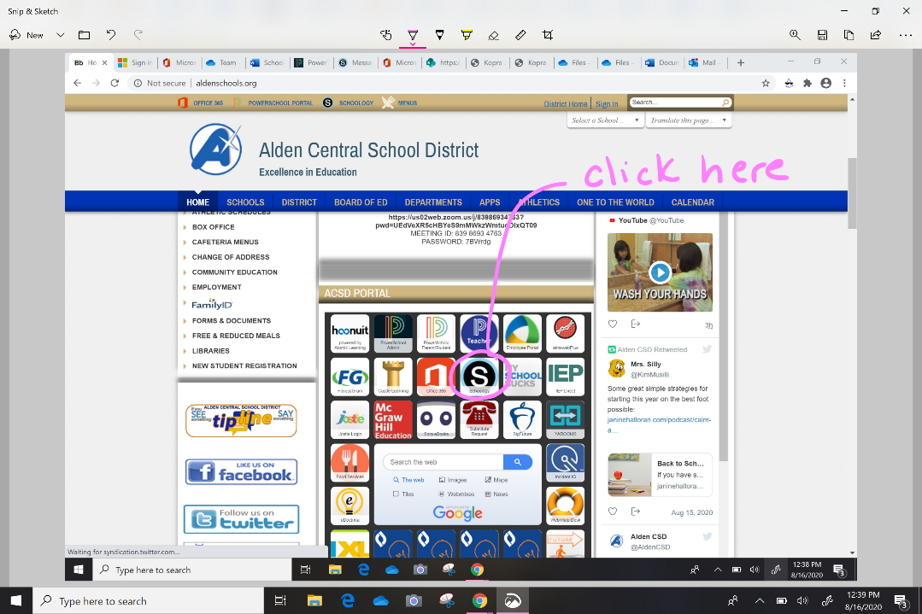

What can I expect to find in Schoology:
- Discussions and posts between teacher and students
- Notifications and messages from teachers
- Published student work (Media Album)
- Pages or folders with class notes or videos posted by the teacher
- Assignments to be completed by student and submitted to the teacher
- Assessments to be completed by the student and submitted to the teacher

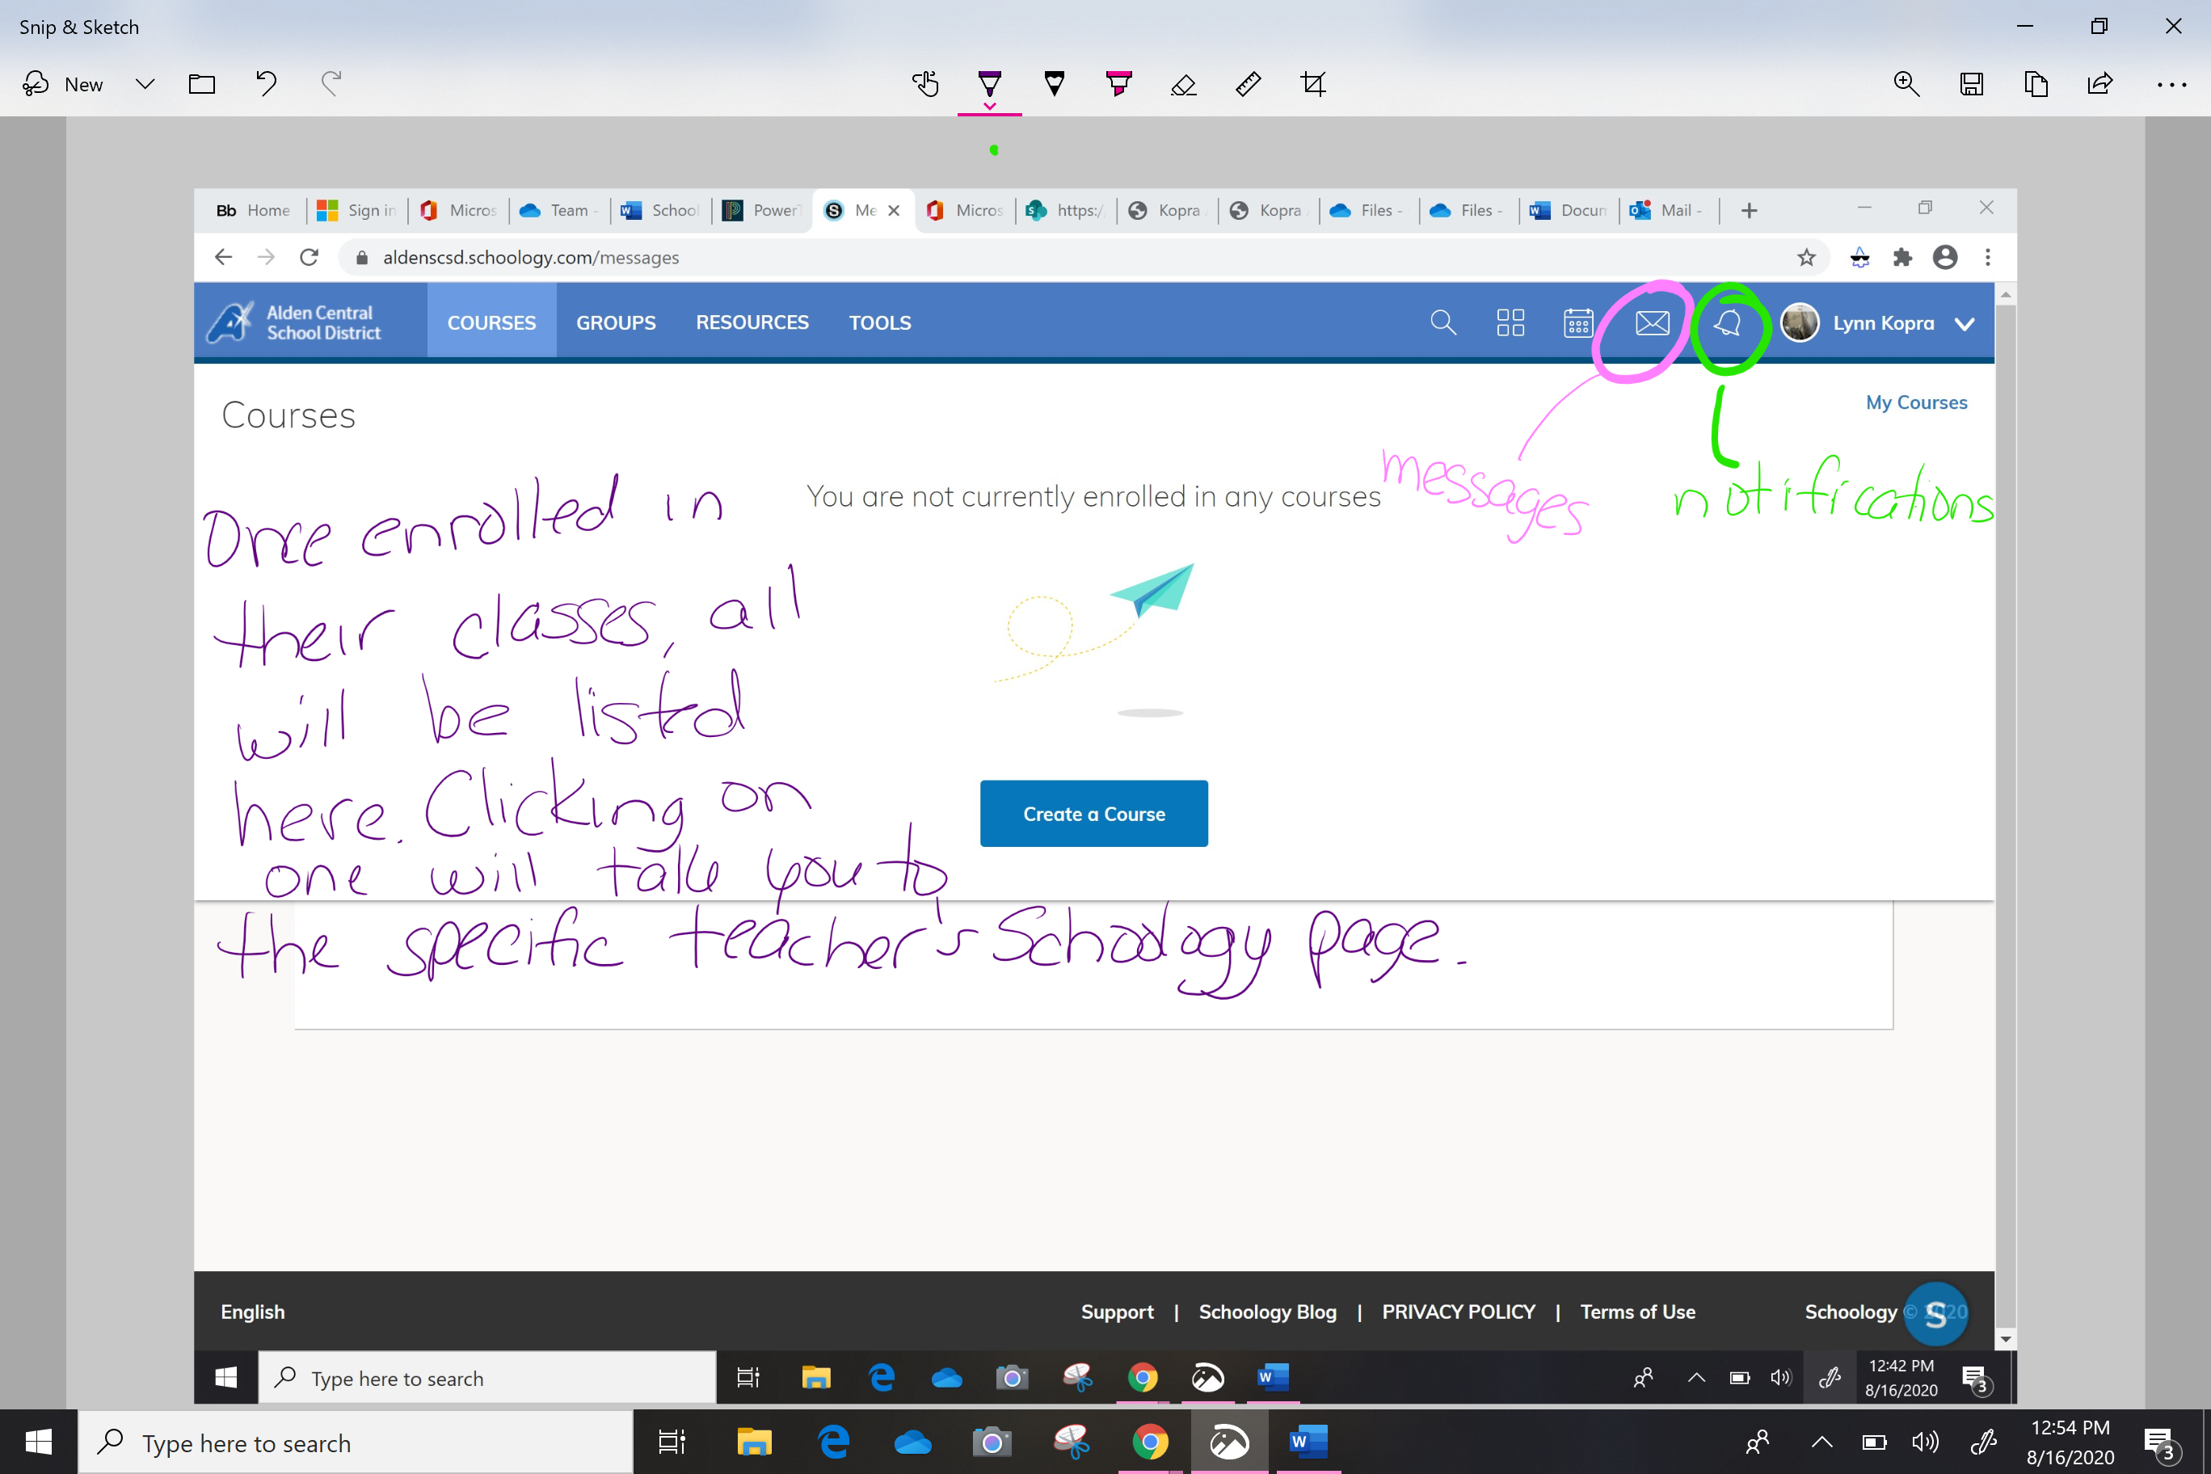

How do I complete and submit an assignment?
- Open the assignment in Schoology.
- Click enable editing.
- Complete the assignment.
- Share the assignments via email.

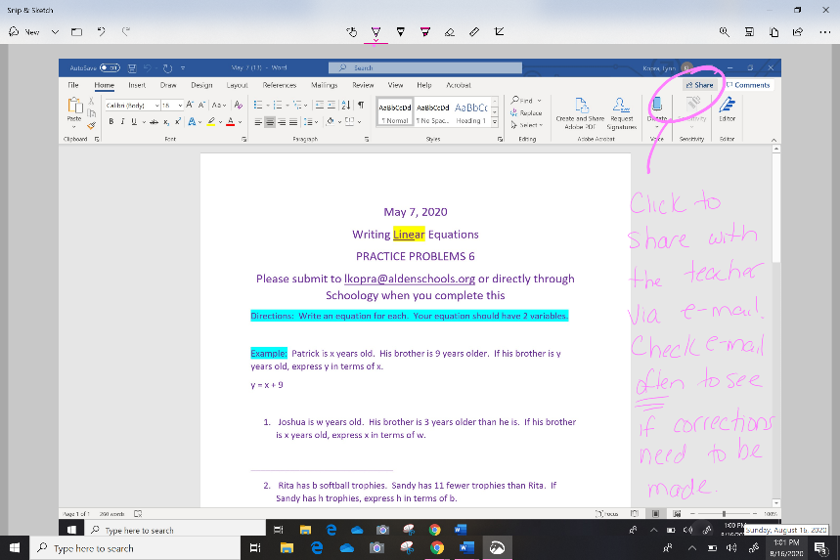
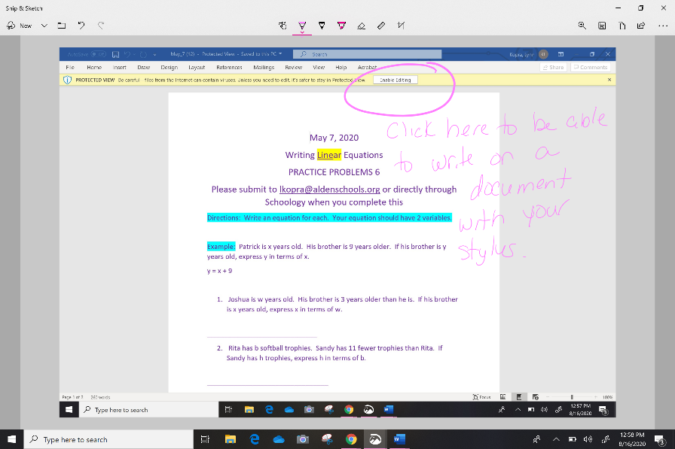

What do I do if I run into a problem with my child’s device or a program that they are using to learn?
- Submit an Incident IQ found on the Alden Home Page.

