Alden Boys Soccer Program 2018

Hello players and parents! This reference info is intended to help us plan for our Fall season and has some new information since my May 31st, 2018 email for Modified, JV, and Varsity Boys Soccer.

- Communication
  - Varsity: Allen Turton IV, aturton@aldenschools.org, school phone 937-9116x4107, cell 785-7194
  - JV: Austin Long 807-2668
  - Modified: Jeffrey Long 481-2524
  - “Remind” App for quick updates and reminders by texting @aldenboys to 81010.
  - Twitter: @aldenmenssoccer
  - Facebook: “Alden Schools Boys Soccer Program” and “Alden Soccer Club”
  - District athletic calendar - games and maps https://aldenseniorhighschool.bigteams.com/main/calendar
  - Varsity Team Stats at www.sectionalsports.com
  - Alden Soccer Club President & Travel Coordinator: Bill Kissell, 912-9864, aldensoccerclub@yahoo.com

- Season Dates - Game schedules for all teams are attached.
  - Varsity and JV Tryouts/Practices will begin on August 13th.
  - Modified Tryouts/Practices will begin on 8/21 and be on Tuesday, Thursday, and Fridays until school starts. Then practices or games will be almost every weekday.
  - A Parent meeting will be held in early August to review program expectations, sign paperwork, review policies and meet the coaches.

- The “To Do List”
  - Get a copy of a recent physical (after 8/20/2017) to the school nurse. No practices without physical.
  - Physical Info … All parents must register their children for modified through varsity sports via an online registration program called Family ID via our school’s athletic page that links to FamilyID. (https://www.aldenschools.org/domain/66)
  - Boys should contact Mr. Kissell about helping Assistant Coach a House Team (this counts for volunteer hours and parent coaches need help) … aldensoccerclub@yahoo.com.
  - Think about and research summer soccer camps. Alden is hosting a Challenger Camp, UB and Houghton have great camps. Next year we are hoping to chose a couple overnight camp options and use our Sports Booster funds to subsidize players costs. Most likely we will have a choice of camps to allow for other summer commitments.

- Playing Time / Tryouts / Cuts
  - Varsity – Best TEAM players will play the most. Developing positional depth is always critical.
  - JV - Target 20 minute minimum for each team member, some players may play the entire game
  - Modified – Target 30 minute for each team member, some players may play the entire game
  - Criteria
    - Effort, attidude and attendance during practices and games
    - Sportsmanship and Team cooperation
    - Skills and positional versatility
  - Ranking – coaches will communicate a ranking at the end of tryouts to each player. This feedback, along with ideas for improvement may help boys decide whether they want to play at the highest team level or stay where originally rostered by grade level. Players often move up or down the ranking during the season. Underclassmen wanting Varsity consideration with get a Varsity and JV ranking.
    - A – Starter, critical to team’s best performance
    - B – Starter, will be substituted 1st
    - C – Non-starter, will play substantial time
    - D – Needs significant improvement (if Varsity, might not play in some games)
    - E – Current skills do not fit within our roster size limits. Train hard for next year.

- Preseason Training – work up to these goals by August 13th to ensure you are in shape for the season.
  - Speed – lunges, squats, toe raises, sprints, leaping over obstacles, shuttle runs, burpees
  - Jog a mile in 8 minutes, jog 2 miles without stopping
  - 3 sets of 20 push-ups alternating with 3 sets of 30 sit-ups
  - Juggle the ball daily with your various body parts (feet, knees, head 50 – 100 consecutive
  - Play every position
  - Watch professional soccer
  - Put down your video game and pick up a ball

- Attendance at all practices and games is expected
  - 8 Team and 6 Individual practices are required prior to a scrimmage (10 and 8 prior to a game)
  - With prior approval, a player may be excused from a practice for a legitimate reason. Examples include: occasional work, another sport practice or game, or family function.
  - These absences will affect your playing time. If something is important to you, you find time.
  - No late bus. Parents often carpool for Varsity, JV and Travel practices and home from games.
  - Practices and games will be at the High School Field. JV games at Town Park (near Community Center).

- Uniforms and apparel
  - The school provides uniforms (jersey, shorts, socks) for all players. Players provide shin guards.
  - Optional Apparel forms were collected in early June and orders should arrive by Mid-August. Thank you Chase Eastland, Justin Evoy and C-Shore Designs for their organizational efforts.
  - Custom Varsity Jerseys have been ordered. Extras (with no name) jerseys were purchased with Sports Booster money largey raised from the Chicken BBQ. Players moved up to varsity that want to keep the uniform and add their name can do so by donating the jersey cost to the Sports Boosters.

Boys Modified Soccer Schedule
Date | Date | Time | Practice |  | Site
8/21 | 9/6 | 3:30-5:30 | practice |  | Alden HS
8/23 | 9/7 | 3:30-5:30 | practice |  | Alden HS
8/24 | 9/10 | 3:30-5:30 | practice |  | Alden HS
8/28 | 9/11 | 3:30-5:30 | practice |  | Alden HS
8/30 | 9/13 | 3:30-5:30 | practice |  | Alden HS
8/31 | 9/14 | 3:30-5:30 | practice |  | Alden HS
9/4 |  | 3:30-5:30 | practice |  | Alden HS
Date | Time | H/A | Opponent |  | Site | Depart
9/17 | 5:00 | home | Holland #1 |  | Alden HS | N/A
9/18 | 5:00 | away | Tonawanda |  | Tonawanda HS | 3:30 PM
9/22 | 10:00 | home | Lackawanna |  | Alden HS | N/A
9/26 | 5:00 | away | Holland - #2 |  | Holland Middle | 3:30 PM
9/29 | 10:00 | home | Springville |  | Alden HS | N/A
10/2 | 5:00 | home | Eden |  | Alden HS | N/A
10/13 | 10:00 | away | Holland #1 |  | Holland Middle | 8:30 AM
10/15 | 4:30 | home | Tonawanda |  | Alden HS | N/A
10/17 | 4:30 | away | Lackawanna |  | Martin Road Elem. | 3:00
10/18 | 5:00 | home | Holland - #2 |  | Alden HS | N/A
10/20 | 10:00 | away | Springville |  | Springville MS | 8:15 AM
10/22 | 5:00 | away | Eden |  | Eden Elementary | 3:00 PM

Current Modified Sign-Ups
# | Last | First | grade
1 | Anthony | Dylan | 8
2 | Hahn | Nathan | 8
3 | Kissell | Kaden | 8
4 | Kozlowski | Adam | 8
5 | Loshiavo | Steven | 8
6 | McCoy | Caiden | 8
7 | Schilling | Lucas | 8
8 | Tenbroeck | Jonathan | 8
9 | Wrest | Gregory | 8
10 | Yoerg | Benjamin | 8
11 | Yoerg | Joshua | 8
12 | Koepf | Ryan | 7
13 | Long | Nathan | 7
14 | Neiman | Riley | 7
15 | Nuwer | Alex | 7
16 | Perry | Xander | 7
17 | Sobieroj | Luke | 7
18 | Speranza | Carter | 7
19 | Stec | Jordan | 7
20 | Wojciechowski | Luke | 7
21 | Zappia | Anthony | 7

JV Schedule and Current Sign-ups
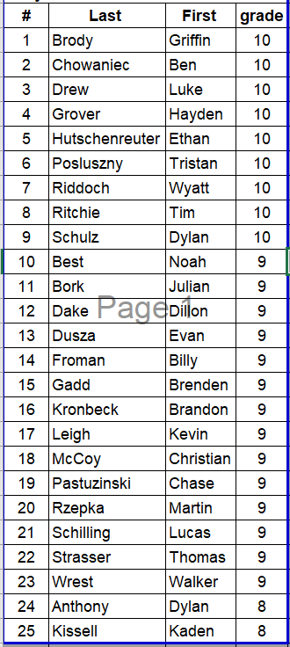
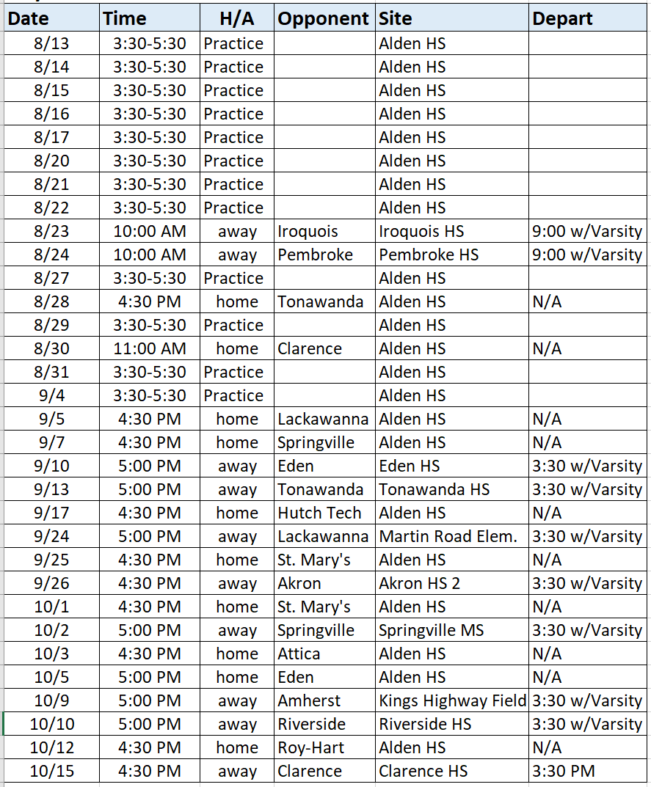

Boys Varsity Soccer Schedule
Date | Time | Type | H/A | Opponent | Site | Depart
8/13 | 3:30-5:30 | Practice |  |  | Alden HS
8/14 | 3:30-5:30 | Practice |  |  | Alden HS
8/15 | 3:30-5:30 | Practice |  |  | Alden HS
8/16 | 3:30-5:30 | Practice |  |  | Alden HS
8/17 | 9:00-11:00 | Practice |  |  | Alden HS
8/20 | 3:30-5:30 | Practice |  |  | Alden HS
8/21 | 3:30-5:30 | Practice |  |  | Alden HS
8/22 | 3:30-5:30 | Practice |  |  | Alden HS
8/23 | 10:00 AM | Scrimmage | A | Iroquois | Iroquois HS | 9:00 AM w/JV
8/24 | 10:00 AM | Scrimmage | A | Pembroke | Pembroke HS | 9:00 AM w/JV
8/27 | 3:30-5:30 | Practice |  |  | Alden HS
8/28 | 4:30 PM | League | H | Tonawanda | Alden HS | N/A
8/29 | 3:30-5:30 | Practice |  |  | Alden HS
8/30 | 5:00 PM | League | A | Holland | Holland Central HS | 3:30 PM
8/31 | 3:30-5:30 | Practice |  |  | Alden HS
9/4 | 3:30-5:30 | Practice |  |  | Alden HS
9/5 | 4:30 PM | League | H | Lackawanna | Alden HS | N/A
9/7 | 4:30 PM | League | H | Springville | Alden HS | N/A
9/10 | 5:00 PM | League | A | Eden | Eden Senior HS | 3:30 PM w/JV
9/13 | 6:30 PM | League | A | Tonawanda | Tonawanda HS | 3:30 PM w/JV
9/17 | 4:30 PM | League | H | Hutch Tech | Alden HS | N/A
9/19 | 6:30 PM | League | H | Holland | Alden HS | N/A
9/24 | 5:00 PM | League | A | Lackawanna | Lackawanna HS | 3:30 PM w/JV
9/26 | 4:30 PM | Non-League | A | Akron | Akron HS 2 | 3:30 PM w/JV
10/1 | 4:30 PM | Scrimmage | A | St. Mary's HS | Westwood Park Turf | 3:30 PM w/JV
10/2 | 5:00 PM | League | A | Springville | Springville MS | 3:30 PM w/JV
10/3 | 4:30 PM | Non-League | H | Attica | Alden HS | N/A
10/5 | 7:00 PM | League | H | Eden | Alden HS (Senior Night) | N/A
10/9 | 5:00 PM | Non-League | A | Amherst | Kings Highway Field | 3:30 PM w/JV
10/10 | 7:00 PM | Non-League | A | Riverside | Riverside High School | 3:30 PM w/JV
10/12 | 4:30 PM | Non-League | H | Roy-Hart | Alden HS | N/A
